# CS 255 System Design Document

This template lays out all the different sections that you need to complete for Project Two. Each section has guidance to prompt your thinking. You will need to continually reference the interview transcript as you work to make sure that you are addressing your client’s needs. There is no required length for the final document. Instead the goal is to complete each section based on what your client’s needs are. Remove this note when you are finished, and replace all bracketed text with the relevant information.

## UML Diagrams

### UML Use Case Diagram

### UML Activity Diagrams

### UML Sequence Diagram

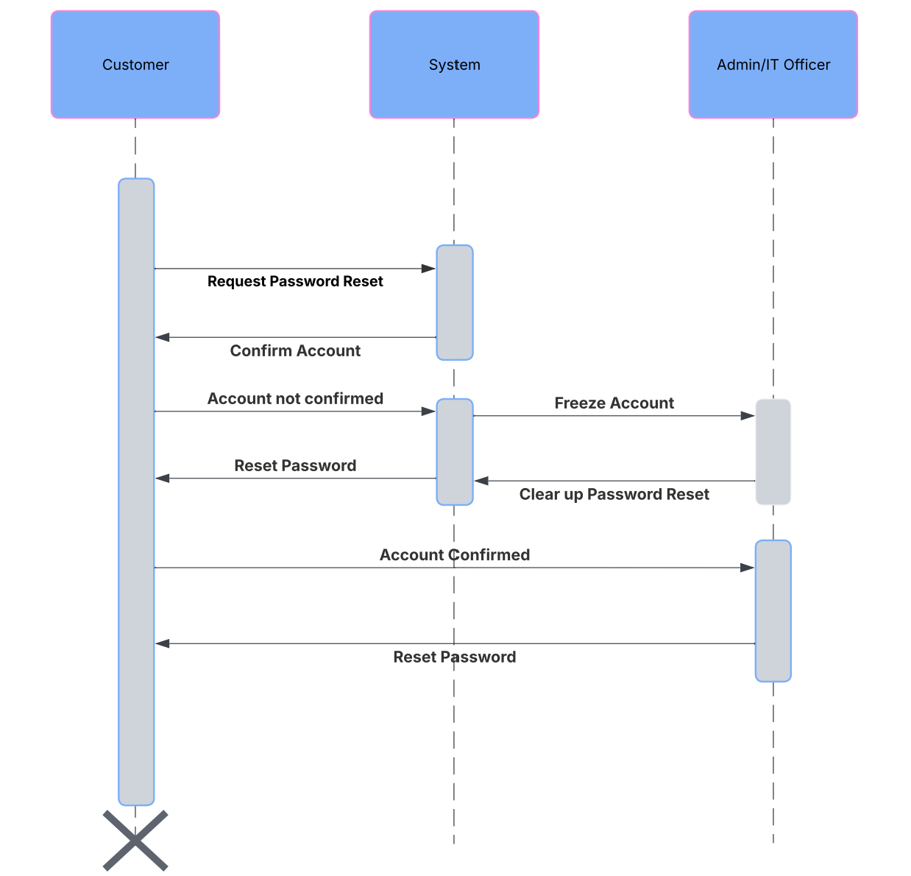

### UML Class Diagram

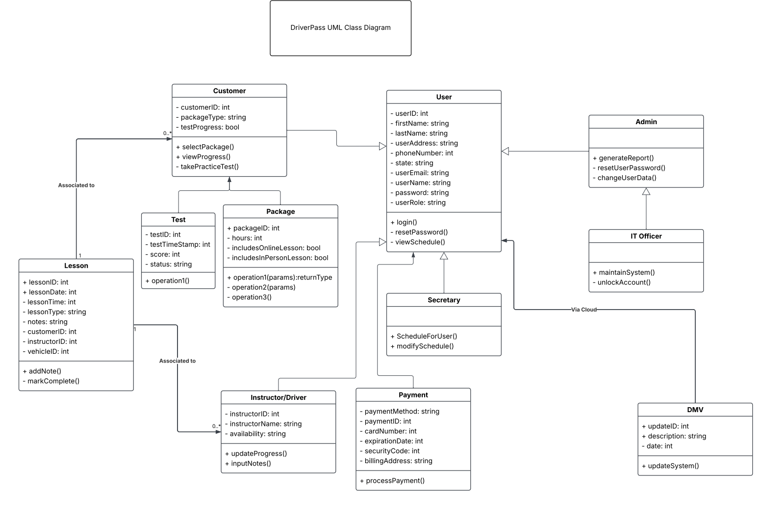

## Technical Requirements

The system would have to include a frontend for the graphics user interface and a backend to handle the system as well. My recommendation for the front-end is JavaScript. It is universally usable on all web browsers and “facilitates real time updates and data manipulation” which is needed for updated information from the DMV. For the backend of the system, I would use an OOP like Java or C++. This will use the class diagram well to create the system and make it easier for maintenance and development. The company would prefer to use an outside source for the cloud for data storage. A system like AWS or Azure would work well for this and they can provide encryption. DriverPass will need servers for their system to run, employees to maintain the system and an office to house all the physical aspects of the company. They will also need very fast internet to provide fast performance and updates to their customers. The most important thing that DriverPass will need is communication. Always communicating with the DMV to update their system will keep them providing their promise of new information. The instructors and customers will communicate using their online system so that each knows who they are looking for when setting up an appointment. The instructors will communicate with the students via feedback and progress reports. The system will communicate with the administrator via logs and reports.